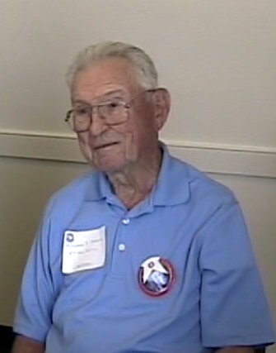
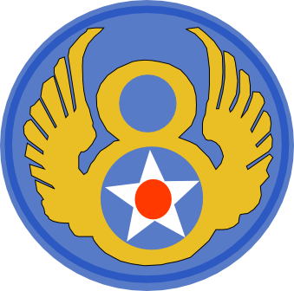
BERNARD STANEK
AMERICAN PILOT
&
D-DAY VETERAN

A CALL TO ACTION
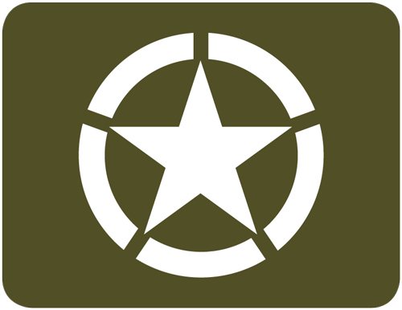
“I always wanted to fly, and I chose it because it was available at that time, all I needed to do is find the area I need to go, so I went to the post office and I some found applications for navy and army cadet flying, so I chose the Army, I turned that in and in just a little while I had the answer.”

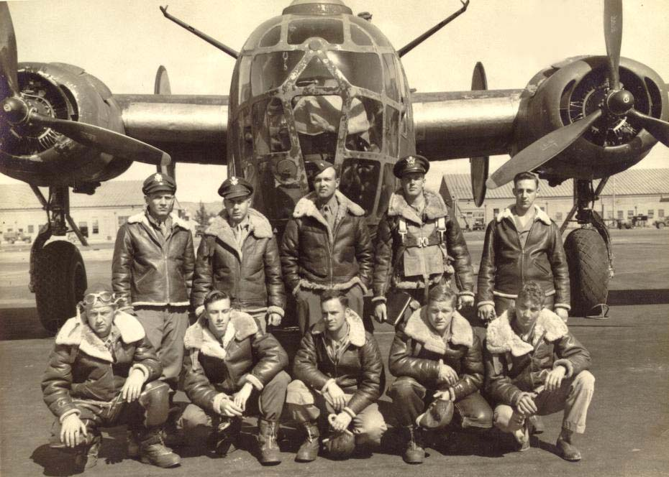
JOINING THE 8th
“ I was with the 8th airforce in the 47th bomb group. I was an operations officer and commander of the 836th squadron. “I was a Major and I was an aircraft leader of a squadron of 12 airplanes.”

THE INVASION OF NORMANDY
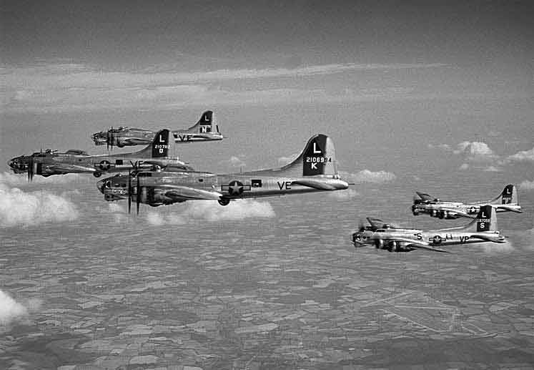
“It had to be that morning, when we got the orders, because, when we were assigned these missions they would come in by tele-type over night, when we got the briefing room, that's when we knew”. “this particular squadron of mine had to be the first one off the ground, in the 8th airforce. Our assignment was to assemble over our marker and as a squadron we flew towards Calais, France and Hitler was parked up there and as far as we knew he said, this is where we are going to invade, so we were called recon and as soon as the radar picked us up, flak did too and imediately I made a 180 and we backed off of there and headed to another target that was assigned to us, it was a small bridge in a small town in front of the British”.

POST NORMANDY OPERATIONS
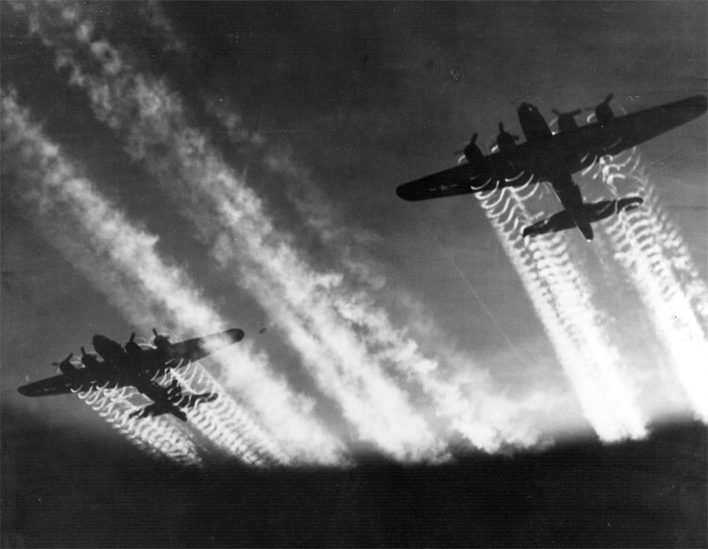
“our target became strategic, that is what we were there for, but for the early part of this battle at Sherber, we were called in two times to bomb the German troops, if you recall, we got stalled out at St. Lowe, we just couldn't bust out of there, so they called upon the 8th airforce heavies to come in there and bomb the German troops. The first assignment, the American troops would have white sheets down to show em were they were and we were to bomb the German troops on the outside. The first wave of bombers was successful, the second wave had too much smoke over our troops and we killed about 250 of our own boys. The next day they changed the assignment and that was the day I flew, and we had to go to eastern end of that part and turn up the line and we ate those 88 flaks all the way to the point we dropped our bomb and they got a shower, but I made a move that saved my own boys. They would drop their bombs and peel out, 12 airplanes doing this, the flak was just so thick there I saw one go down and the other staggering in front of me. And the moment after we dropped our bombs I yelled out, “we're gonna start and stop, were gonna go 10 more seconds and then were gonna turn” and all the flak was to our right, we hardly got a scratch, a split decision, just like that helped us that much, I got accomidation for it but I didn't get any medals for it, or an increased salary or anything like that”.

PRIDE FOR SERVICE
“I think it's been an asset, really, I believe I have become more sure of myself, it a way to really prove your capabilities and that helped, im sure, of course it was tough to see, I have see airplanes blow up I have seen guys in parachutes, he never got see the opening of his parachute, but I always had some one in my airplane watching, to count the guys on the planes as they went down. I had a really good relationship with the pilots of each of those crews and it made a difference, and when I go to thses reunions there is a lot of respect especially for what I did for the bomb group”.

